

Database User Manual
10/04/2018

USER'S MANUAL
TABLE OF CONTENTS
Page #
1.0 GENERAL INFORMATION 1
1.1 System Overview 1
1.2 Project References 1
1.3 Organization of the Manual 1
2.0 SYSTEM SUMMARY 2
2.1 System Configuration 2
2.2 Contingencies and Alternate Modes of Operation 2
3.1 System Menu 3
3.1.1 Main Interface 3
3.1.2 New Hero 3
3
3.1.3 New Enemy 4
3.1.4 New Skill 4
3.1.5 Heroes Skills 5
3.1.6 Enemies Skills 6
6
3.1.7 Delete Entry 6
Users are able to permanently remove a customer from the database by clicking on the button to the right of the “Insert/Update” button labeled “Delete”. Following this, they are shown a warning message to help prevent accidental deletion. Finally, the user is able to scroll to an Entry and remove their information from the database. 6
3.2 Exit System 6
4.0 QUERYING 7
4.1 Querying 7
4.2 Query Capabilities 7
4.3 Query Procedures 7
5.0 REPORTING 8
5.1 Reporting 8
5.2 Report Capabilities 8
5.3 Report Procedures 8

1.0 GENERAL INFORMATION

GENERAL INFORMATION

1.1 System Overview

The system is designed to allow the user to seamlessly enter in data for various entities (Such as hero, enemy, skills, etc.) using pre-programmed, easy-to-use forms. The information entered into the forms is then warehoused in a database. Users are then capable of generating many various reports based on the information in the database. The system is also capable of using Microsoft Excel to efficiently import and export data.

The system is designed to run on Microsoft Access 2007 or later versions that support the system.

1.2 Project References

The following is a list of the references that were used during development of the system:

- Microsoft Access 2016
- Microsoft Word 2016
- Microsoft Excel 2016

1.3 Organization of the Manual

This manual is divided into 5 major sections, listed and defined below.

- – General Information: Contains basic information about the program, such as functions performed and a description of the program.

- – System Summary: This section provides a general overview of the system.

- – Getting Started: This section provides a general walk-through guide to the system, from beginning to exit.

- – Querying: This section describes the query and retrieval capabilities of the system.

- – Reporting: This section describes the various reports that can be generated by the system.

SYSTEM SUMMARY

2.1 System Configuration

Users are provided with a GUI (Graphical User Interface) to interact with the database to complete tasks such as data insertion, data deletion, data modification, along with various queries and reports.

2.2 Contingencies and Alternate Modes of Operation

Regular backups should be performed, due to the fact that in the event of an emergency and/or accident, stored data could become lost.

3.0 GETTING STARTED

3.1 System Menu

3.1.1 Main Interface
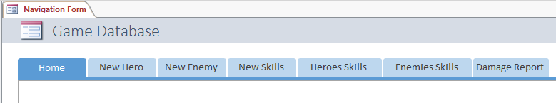

Upon launching the system, users are presented with the main interface (pictured above). By clicking the labeled tabs, users are capable of accessing the following tabs:

- New Enemy
- New Hero
- New Skills
- Heroes Skills
- Enemies Skills

3.1.2 New Hero

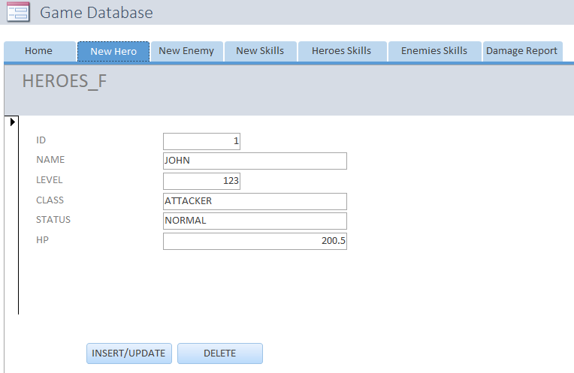

By clicking on the New Hero tab, users are able to easily create a record of a new Hero. Users simply click the “Insert/Update” button located at the bottom of the form after they enter the requested information which is the ID, Name, Level, Class, Status and HP into the form, and the Hero is stored in the database.

3.1.3 New Enemy
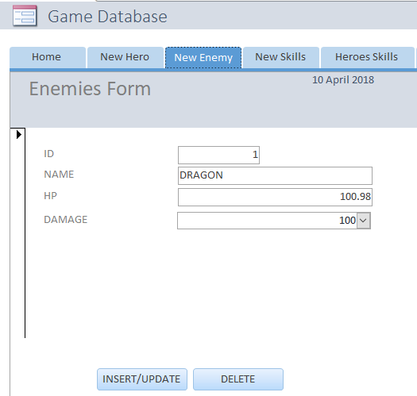

By clicking on the New Enemies tab, users are able to easily create a record of a new Enemy. Users simply click the “Insert/Update” button located at the bottom of the form after they enter the requested information which is the ID, Name, HP and Damage into the form, and the Enemy is stored in the database.

3.1.4 New Skill

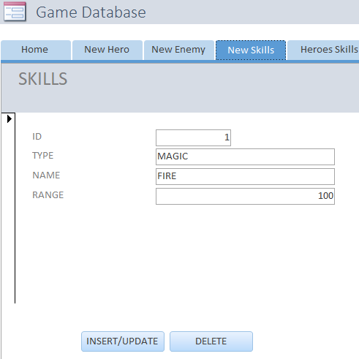

By clicking on the New Skill tab, users are able to easily create a record of a new Skill. Users simply click the “Insert/Update” button located at the bottom of the form after they enter the requested information which is the ID, Type, Name and Range into the form, and the Skill is stored in the database.

3.1.5 Heroes Skills

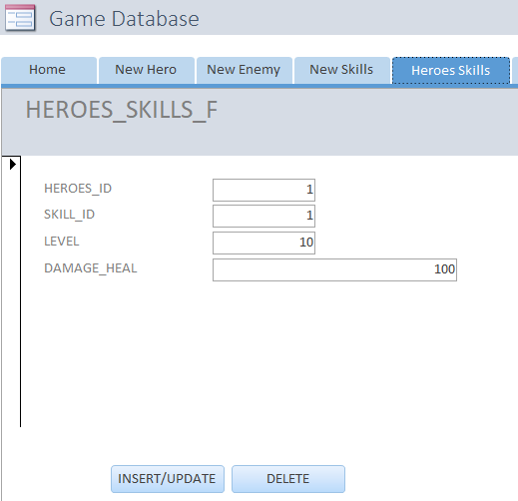

By clicking on the Heroes Skills tab, users can easily create a record of a Skill for the Heroes of the Game. Users simply click the “Insert/Update” button located at the bottom of the form after they enter the requested information which is the Hero ID, Skill ID, Level and Damage Heal into the form. This then defines a skill from the skill table to the hero in the hero table.

3.1.6 Enemies Skills

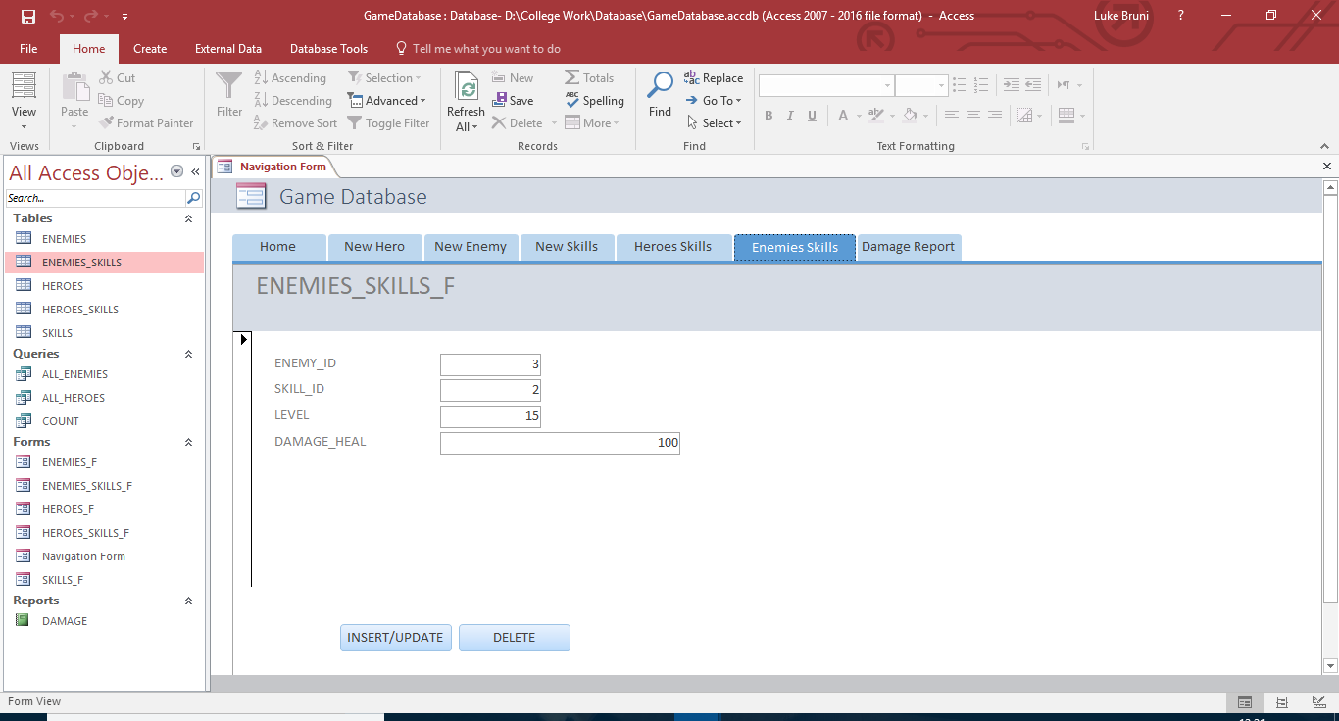
By clicking on the Enemies Skills tab, users can easily create a record of a Skill for the Enemies of the Game. Users simply click the “Insert/Update” button located at the bottom of the form after they enter the requested information which is the Enemy ID, Skill ID, Level and Damage Heal into the form. This then defines a skill from the skill table to the Enemy in the Enemy table.

3.1.7 Delete Entry

Users are able to permanently remove a customer from the database by clicking on the button to the right of the “Insert/Update” button labeled “Delete”. Following this, they are shown a warning message to help prevent accidental deletion. Finally, the user is able to scroll to an Entry and remove their information from the database.

3.2 Exit System

Users should ensure that all of their changes and input have been saved in the database. Once their information has been saved, the user can either click the Microsoft ribbon, followed by Exit Access.

A secondary exit method available to the user is the x button located in the top right of the screen.

4.0 QUERYING

4.1 Querying

This section describes the query and retrieval capabilities of the system. The instructions necessary for recognition, preparation, and processing of a query applicable to a database shall be explained in detail.

4.2 Query Capabilities

There are various query capabilities pre-programmed into the system, available to the user by a variety of easy-to-use buttons on the left-hand side of the screen. These queries are accessible by clicking on sentences following the Query Icon ()

Count Hero: Allows the user to count the amount of heroes in a table with a set parameter of their choosing, such as desired level or skill.

All Enemies: Allows the user to see all the enemies in the enemies table.

4.3 Query Procedures

Users can access particular queries by clicking on the desired query, denoted by the Query Icon (), and then following the prompts that follow.

For example, to perform a Search Customer query:

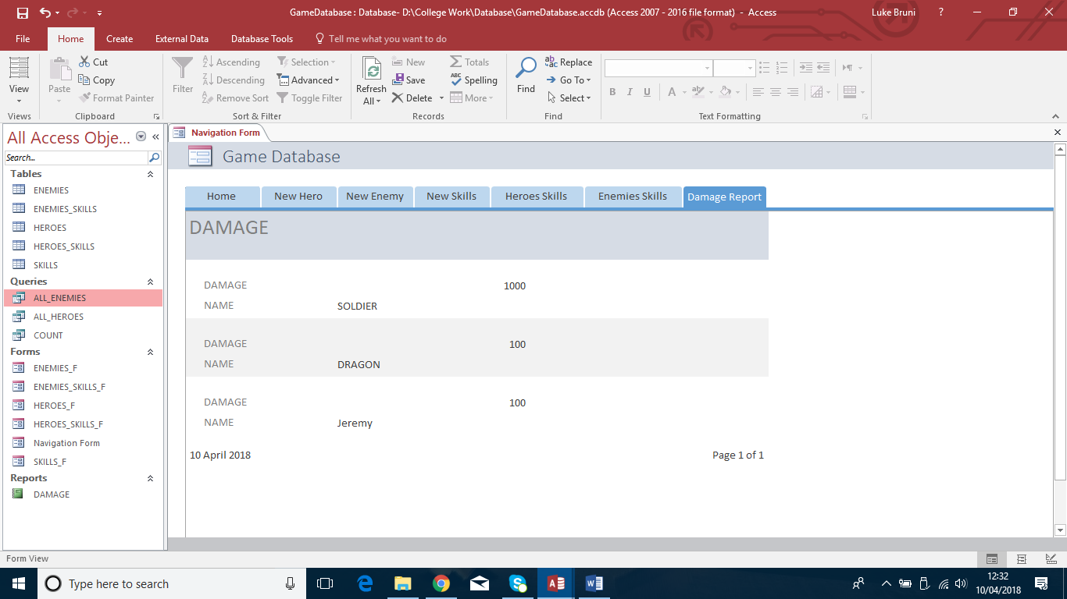

Users would click the ALL_ENEMIES QUERY, which would show all the enemies of that table, shown below:

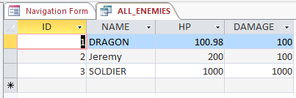

5.0 REPORTING

5.1 Reporting

This section describes and depicts all standard reports that can be generated by the system or internal to the user.

5.2 Report Capabilities

The user is capable of generating various reports, such as:

Viewing a list of all Entities in the database
Report of all skills regarding a particular amount of damage.
These are available on the left-hand side of the window, marked by the Report icon ()

5.3 Report Procedures

In order to access these reports, double-click on the desired report, and then follow the prompts that follow.

For example, to run a report showing Damage of each particular enemy, users would first double-click on the report marked “DAMAGE”
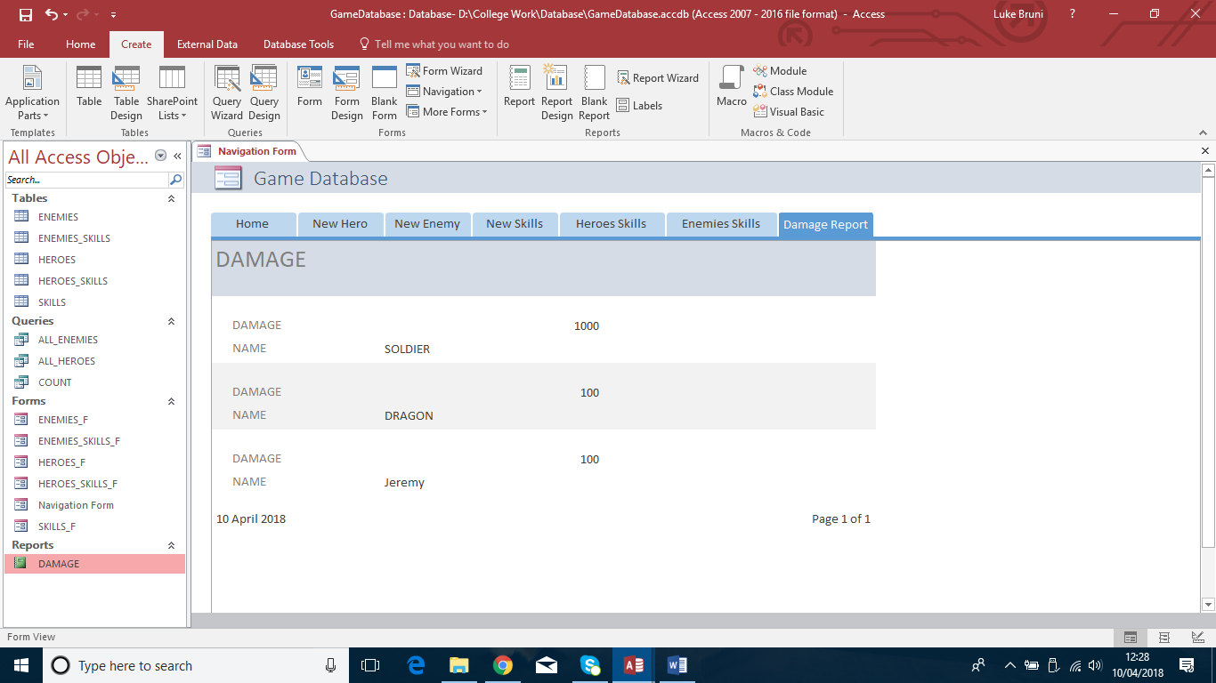.

And then, the report is generated and displayed to the user:
